# Setting Up ci and cd for api app

## Create account in vsts

1. Login to VSTS URL:
   1. <https://app.vsaex.visualstudio.com/me?mkt=en-US&campaign=o_msft_acom_vsts_hero>
2. Click on ‘Create New account’

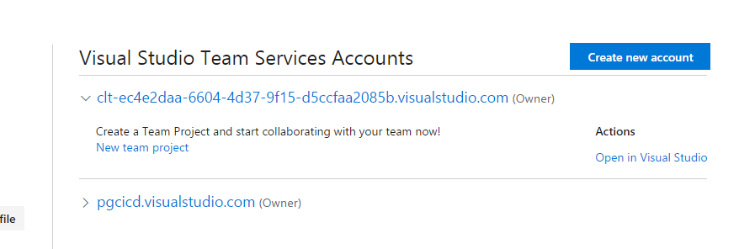

1. Enter below highlighted fields. For Name, enter ‘pgcicd’. Click ‘Continue’.

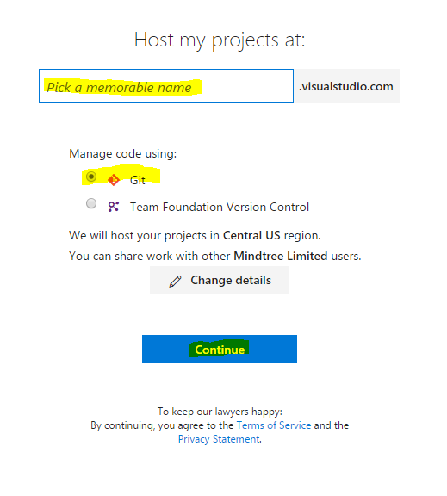

1. On successful creation will get below screen:

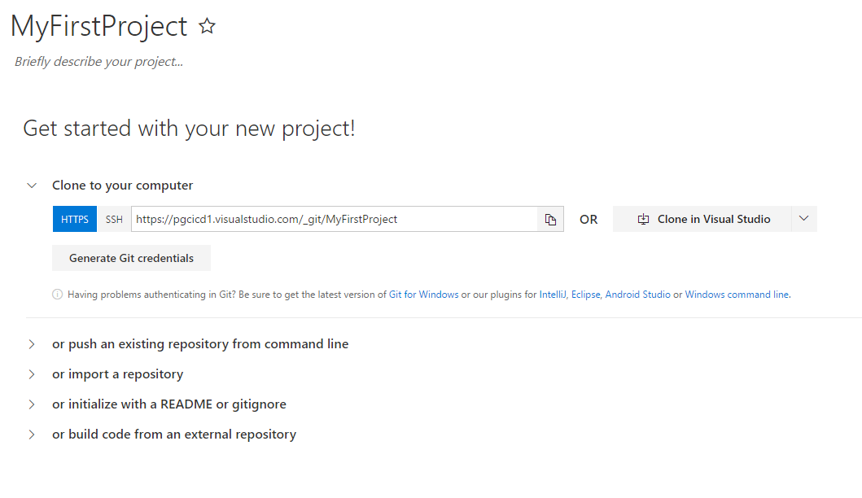

1. Go to home page of this VSTS instance, and click on ‘New Project’:

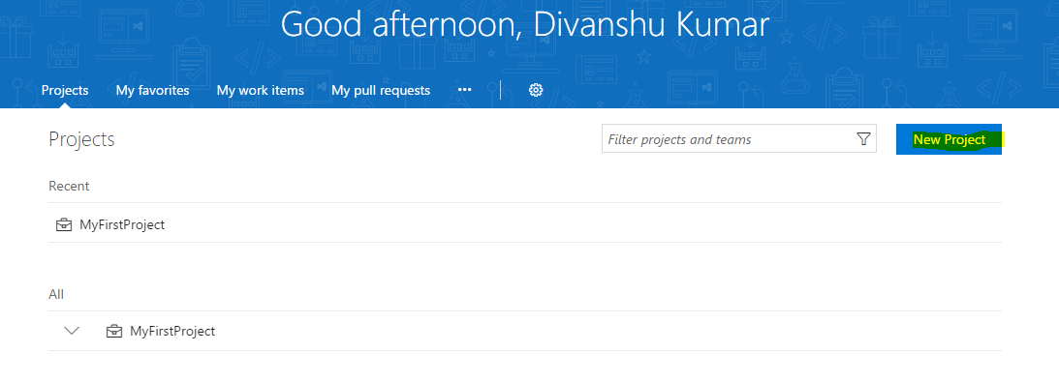

1. Enter details as highlighted and click ‘Create’.

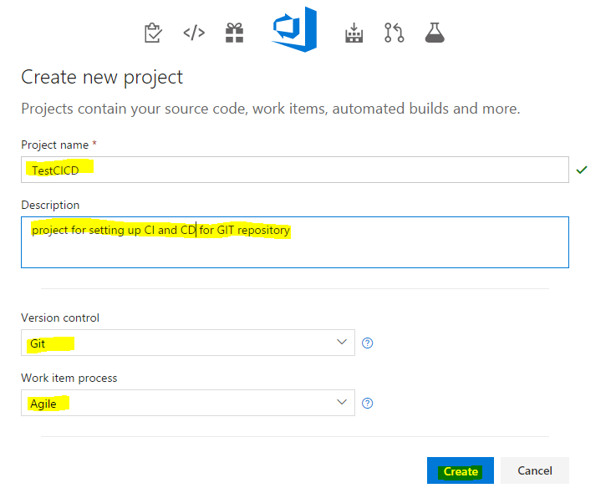

1. Once successfully created, next step to set up CI and CD in Azure Portal.

## Configure CI and CD for Azure api app

1. Login to Azure Portal, and navigate to respective resource group -> Azure API APP.

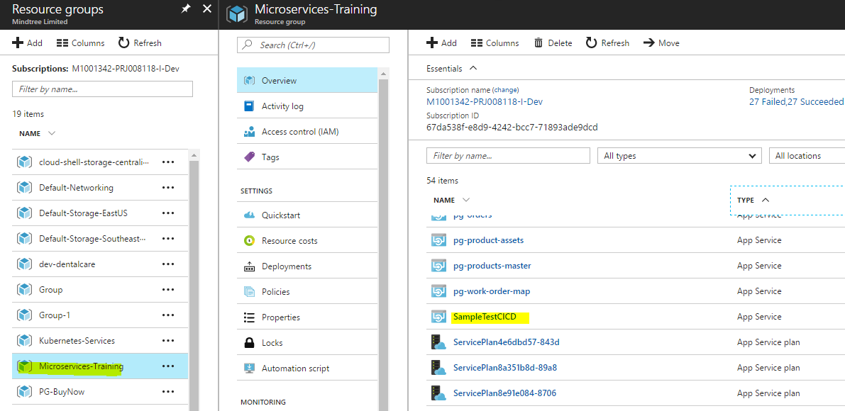

1. Note: Recommended to set up Azure API APP correctly before configuring CI and CD.
2. Navigate to ‘Continuous Delivery (Preview)’.

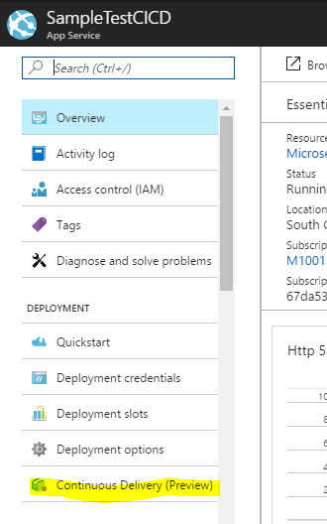

1. Click on ‘Configure’:

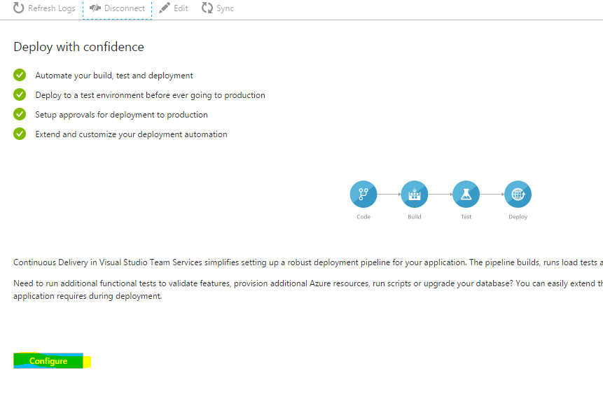

1. Enter details for repository. In case Github selected, select the repository selected for Azure API APP. Click Ok.

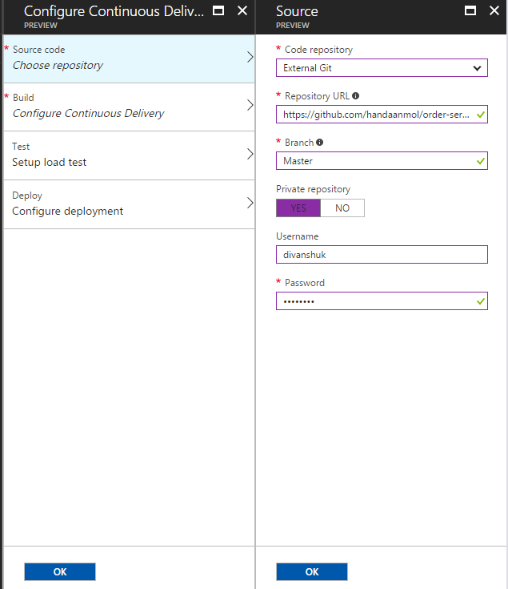

1. For ‘Configure Continous Delivery’. Enter highlighted details. Click Ok.

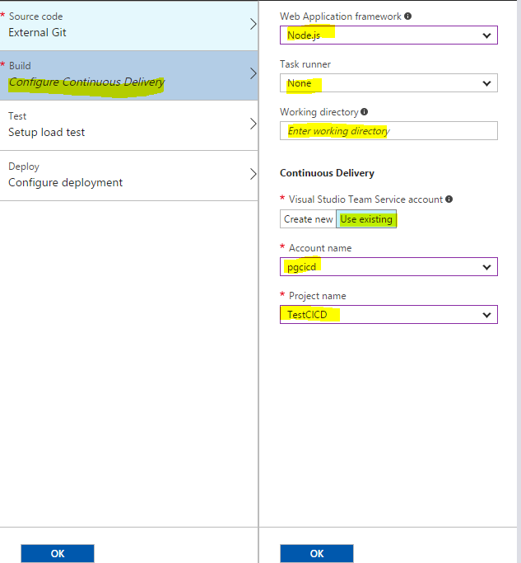

1. For ‘Deploy’: enter below highlighted details. Click OK.

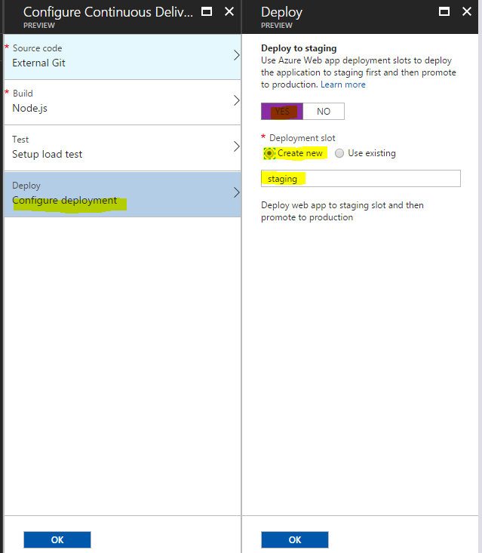

1. Click OK.
2. On Successful creation, will get below screen.

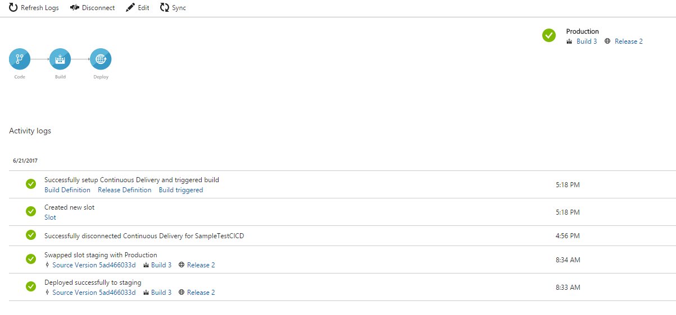

1. Click on ‘Build Definition’.

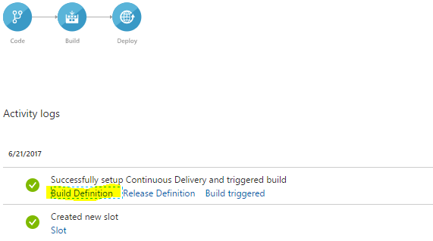

1. In the new window, click on ‘Edit’ to modify the build definition.

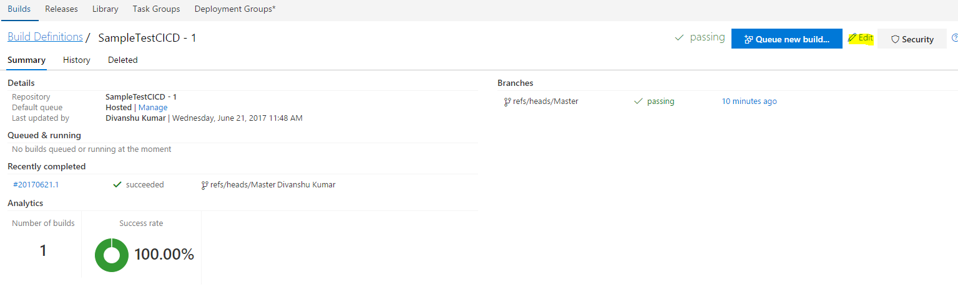

1. Enable the trigger and auto-schedule the build based on requirement from below screen.

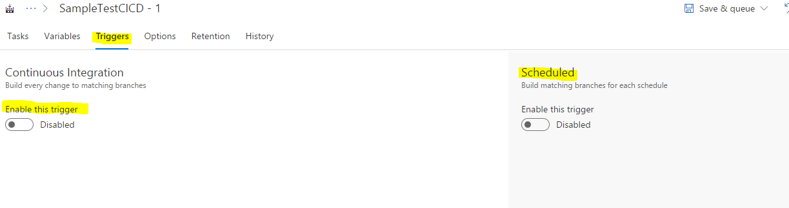

1. Click on ‘Save’ and exit.

